**DAILY ONLINE ACTIVITIES SUMMARY**

|  |  |  |  |  |  |  |  |  |
| --- | --- | --- | --- | --- | --- | --- | --- | --- |
| **Date:** | **5-06-2020** | | | | | **Name:** | **Kavya** | |
| **Sem & Sec** | **6th & A** | | | | | **USN:** | **4AL17CS041** | |
| **Online Test Summary** | | | | | | | | |
| **Subject** | | **Operation Research** | | | | | | |
| **Max. Marks** | | **30** | | **Score** | | | **30** | |
| **Certification Course Summary** | | | | | | | | |
| **Course** | Unveiling the mysteries of multithreading in Java. The ultimate Java multithreading course | | | | | | | |
| **Certificate Provider** | | | **udemy** | | **Duration** | | | **3 hours** |
| **Coding Challenges** | | | | | | | | |
| **Problem Statement:1.** Write a Java program to implement Circular Linked List Using Array And Class  2. Python program to square each odd number in the list | | | | | | | | |
| **Status:Yes I have uploaded all the programs** | | | | | | | | |
| **Uploaded the report in Github** | | | | | **Yes** | | | |
| **If yes Repository name** | | | | | [**https://github.com/kavya-077/DAILY-STATUS**](https://github.com/kavya-077/DAILY-STATUS) | | | |
| **Uploaded the report in slack** | | | | | **Yes** | | | |

Online Test Details: (Attach the snapshot and briefly write the report for the same)

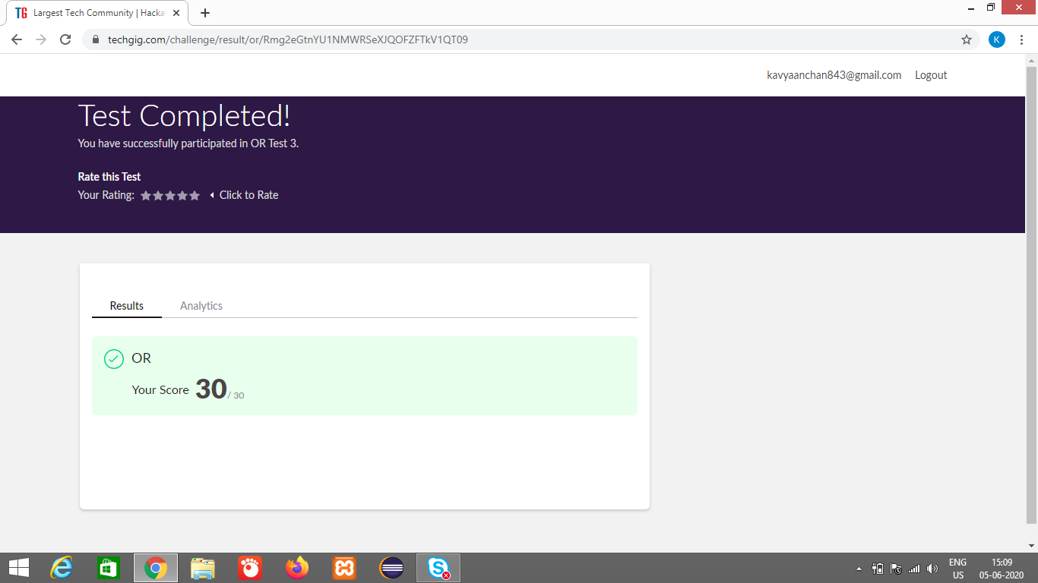

Certification Course Details: (Attach the snapshot and briefly write the report for the same)

**Unveiling the mysteries of multithreading in Java. The ultimate Java multithreading course**

**What we’ll learn**

* Understand Java multi-threading
* Be able to write effective muli-threaded code

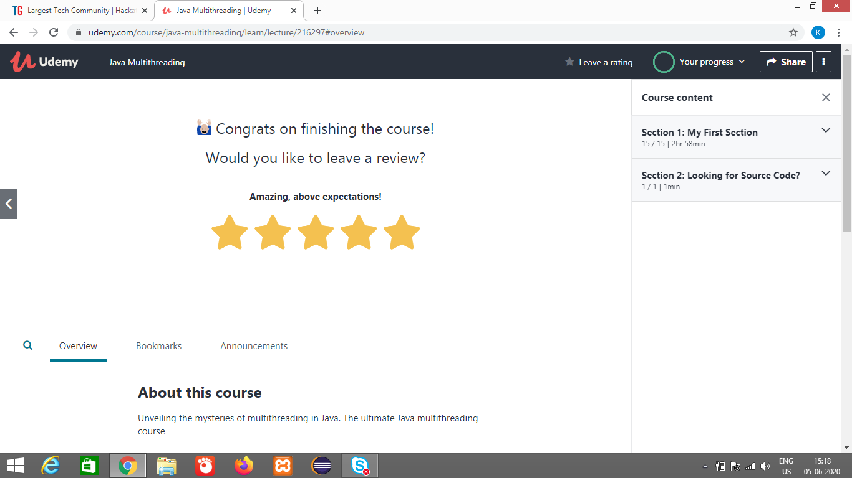

<https://github.com/alvas-education-foundation/kavya-onlinecourse>

Coding Challenges Details: (Attach the snapshot and briefly write the report for the same)

<https://github.com/alvas-education-foundation/kavya-OCA>

<https://github.com/kavya-077/DAILY-STATUS>